**NATIONAL INTEGRATION**

* Integration is an act of bringing together smaller components into a single system that function as one.
* Integration of different groups of people into a single framework or with in a single umbrella is called national integration.
* The bond and togetherness between people regardless of their caste, creed, religion or gender.
* It is the feeling of oneness, brotherhood and emotional attachment towards the people, soil, national language, flag, etc.
* It is also an awareness that though the individual belongs to different communities, castes, religions, cultures and regions and speak different languages, all of them recognize that they are one.

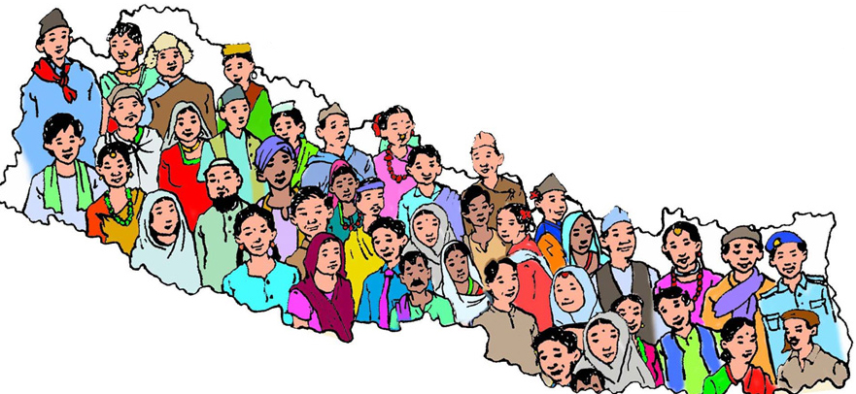

*Example of National Integration.*

**DEFINITIONS**

The people below have defined national integration as such:

* According to **Rajan Roy**, “*National integration is a kind of participation by all groups of people in the main stream and it means to be integrated into a common whole from social, political, cultural, administrative and social relationships”*
* According to **Dr Harka Gurung** , *“Integration is a political idea which is ideal. It implies a national state where all citizens have full rights without any form of segregation. He emphasizes upon socio-cultural dimension and economic dimension for the integration.”*

**Elements of National Integration**

The characteristics of national integration is given below:

1. **Socio-cultural dimensions**

The definition of socio-cultural is something that involves the social and cultural aspects. An example of socio-cultural is knowing about the people around you and their family background.

1. **Economic dimensions**

The distribution of wealth and income is one of the indicators of measuring economic equality in the country. The term economy is related with the process of production, distribution, consumption and the exchange of goods and services.

1. **Psychological dimensions**

On the emotional front, national integration desires passionate attachment of the people with their flag, national anthem, symbols, myths, slogan, historic figures, etc.

1. **Political Dimensions**

The condition of sharing power by the people of different strata at the stare affairs, where the state attempts to create a congenial atmosphere in order to secure people’s genuine participation.

1. **Administrative Dimensions**

Nepal has been divided into administrative units. The first level of country subdivisions of Nepal are the provinces. Each province is further subdivided into Districts and Districts into Municipalities and rural municipalities.

**PRESENT ISSUES**

1. Ethnic issues
2. Linguistic issues
3. Regional issues